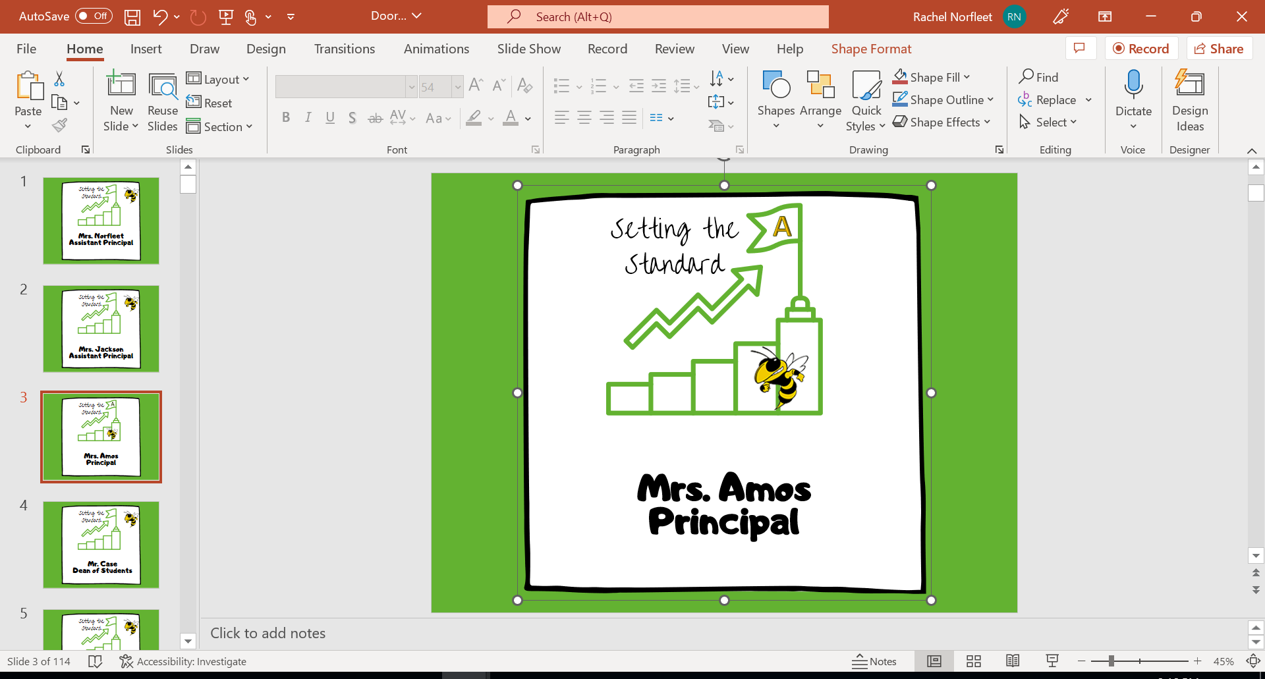
Wednesday
1st period – 9:00-9:41
2nd period – 9:45-10:24
3rd period – 10:28-11:07
4th period – 11:11-12:36
1st lunch – 11:07-11:36
2nd lunch – 11:37-12:06
3rd lunch – 12:07-12:36
5th period – 12:40-1:19
6th period – 1:23-2:02
7th period – 2:06-2:45

